**Computer Interfacing**

**CSE-405**

**Microsoft HoloLens**

**Group Members:**

Ayon Roy Shouhag 201714018

M Aqib Alfaz 201714024

Md Nafiz Imtiaz Saimon 201714034

**Microsoft HoloLens**

Microsoft HoloLens is the first holographic computer, powered by Windows 10. It is completely unattached ( no wires, phones, or connection to a PC needed). It is the fully untethered holographic computer enabling high definition holograms to integrate with your world.Microsoft HoloLens Place holograms in your locations you choose and your digital content will feel more real than ever before.

**Augmented Reality**

Augmented reality is a live direct or indirect view of a physical, real-world environment whose elements are augmented by computer-generated sensory input such as sound, video, graphics and data.

**Applications of HoloLens:**

* Medical
* Entertainment
* Educational
* Industrial
* Shopping
* Research
* Communication

**Features:**

* **Visualization:** HoloLens enables the user to visualize surroundings which are not directly visible. It can get visual insight into an object or model. It can be used for modeling of non-existing objects.
* **Education:** HoloLens helps students through experiential learning. It helps students with more realistic teaching by moving 2D presentations in books to 3D holographic models
* **Working together:** HoloLens supports through linked view, voice and gestures. It enables meetings around Holographic objects. It helps in working together on projects whereby visualization is an important part. It helps working together when distance is involved.
* **Media & entertainment:** HoloLenshas enriched media with additional holographic objects. We can play games as part of our real-world environment.

**Components:**

* An [Intel](https://en.wikipedia.org/wiki/Intel) [Cherry Trail](https://en.wikipedia.org/wiki/Atom_(system_on_chip)) [SoC](https://en.wikipedia.org/wiki/System_on_a_Chip) containing the [CPU](https://en.wikipedia.org/wiki/Central_processing_unit) and [GPU](https://en.wikipedia.org/wiki/Graphics_processing_unit).
* A custom-made Microsoft Holographic Processing Unit (HPU), a [coprocessor](https://en.wikipedia.org/wiki/Coprocessor) manufactured specifically for the HoloLens.
* SoC and HPU each have 1GB [LPDDR3](https://en.wikipedia.org/wiki/LPDDR3) and share 8MB [SRAM](https://en.wikipedia.org/wiki/Shadow_Random_Access_Memory).
* SoC also controls 64GB [eMMC](https://en.wikipedia.org/wiki/EMMC) and runs the [Windows 10](https://en.wikipedia.org/wiki/Windows_10) [operating system](https://en.wikipedia.org/wiki/Operating_system).
* HPU uses 28 custom [DSPs](https://en.wikipedia.org/wiki/Digital_signal_processors)(Digital Signal Processor) from [Tensilica](https://en.wikipedia.org/wiki/Tensilica) to process and integrate data from the sensors, as well as handling tasks such as spatial mapping, [gesture recognition](https://en.wikipedia.org/wiki/Gesture_recognition), and [voice](https://en.wikipedia.org/wiki/Speaker_recognition) and [speech recognition](https://en.wikipedia.org/wiki/Speech_recognition).
* An [inertial measurement unit](https://en.wikipedia.org/wiki/Inertial_measurement_unit) (IMU) (which includes an [accelerometer](https://en.wikipedia.org/wiki/Accelerometer), [gyroscope](https://en.wikipedia.org/wiki/MEMS_gyroscope), and a [magnetometer](https://en.wikipedia.org/wiki/Magnetometer))four "environment understanding*"* sensors (two on each side).
* An energy-efficient [depth](https://en.wikipedia.org/wiki/Range_imaging) camera with a 120°×120° [angle of view](https://en.wikipedia.org/wiki/Angle_of_view).
* A 2.4-megapixel photographic video camera.
* A four-[microphone array](https://en.wikipedia.org/wiki/Microphone_array).
* An [ambient light sensor](https://en.wikipedia.org/wiki/Ambient_light_sensor).
* An [IEEE 802.11ac](https://en.wikipedia.org/wiki/IEEE_802.11ac) [Wi-Fi](https://en.wikipedia.org/wiki/Wi-Fi) and [Bluetooth 4.1](https://en.wikipedia.org/wiki/Bluetooth_4.1) [Low Energy](https://en.wikipedia.org/wiki/Bluetooth_low_energy) (LE) wireless connectivity.

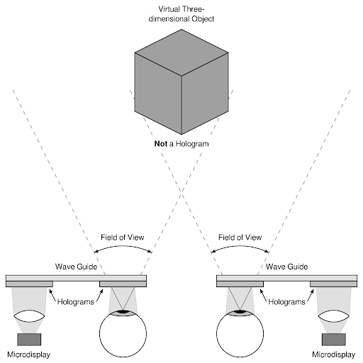**Working Principle:**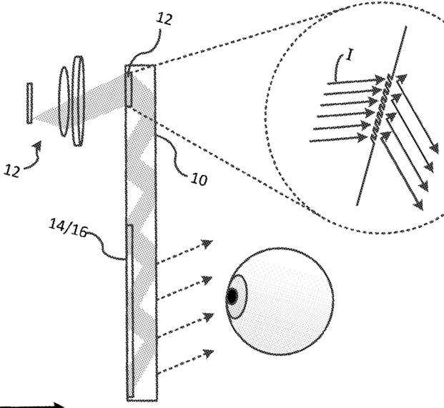

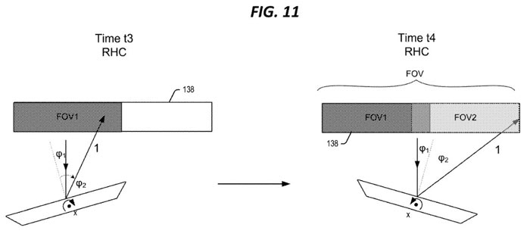

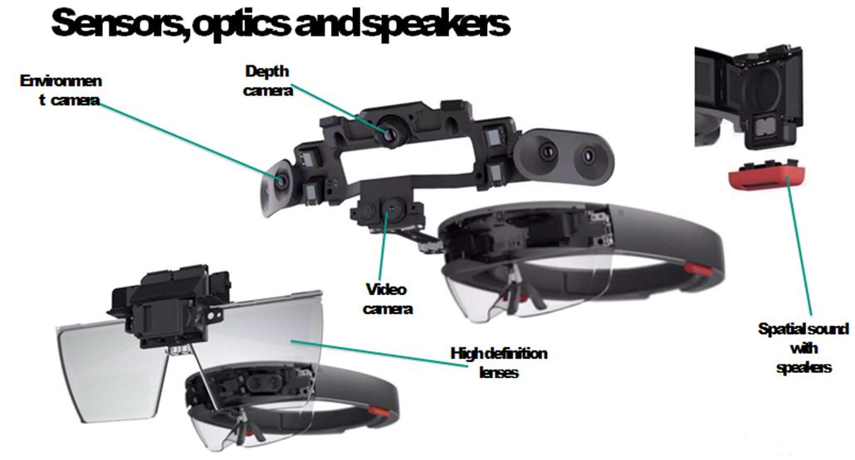

**Interface Design:**

The HoloLens consists of

* **Computer**: HoloLens is not just a visor connected to a computer, it is a computer on its own.HoloLens contains CPU, battery, GPU and first of its kind HPU (holographic processing unit). 18 sensors flood the brain of the device with terabyte of data every second.
* **Camera**: The HoloLens depth camera has a field of vision that spans 120 by 120 degrees, so it can sense what your hands are doing even when they are nearly outstretched.
* **Sensors**: Sensors track where the wearer is looking and adjust the display.
  + Motion sensors detect wearers movement.
  + The sensor can also see wearers’ hands, the hands are an Input system. Users can interact with whatever they see by just touching it.
  + Wearers also give gestures as the input sensor enables the tracking of user movement.
* **Vent**: The device is more powerful than a laptop but won’t overheat- warm air flows to the sides, where it vents up and out.
* **Buttons**: On the right side buttons allow the user to adjust the volume and to control the contrast of the hologram.

**Related Works:**

* Google Glass
* Apple Glass(upcoming)
* Oculus Rift